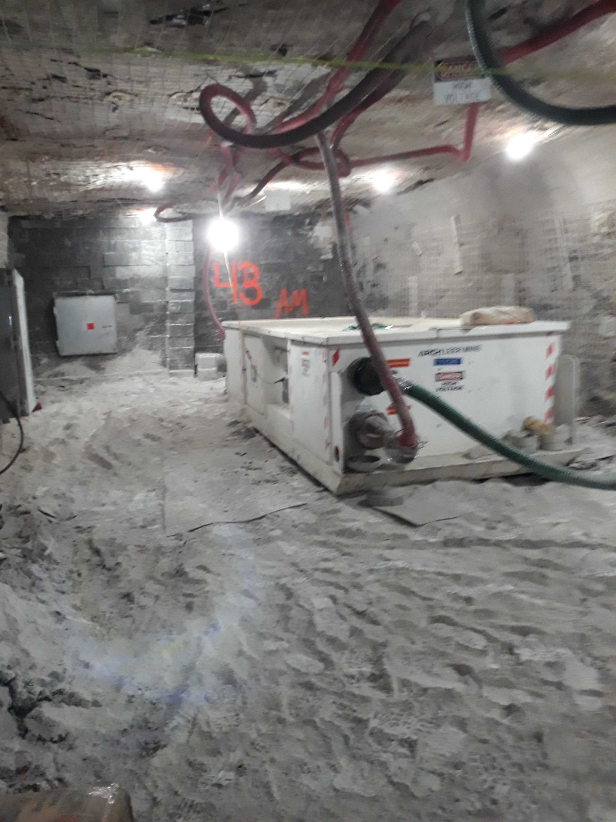

Electrical Examination Database Software Manual

software Version 0.3.3

Francis Enterprises Inc

20 Monongahela Ave

WESTOVER, WV 26501

Table of Contents

Revisions: 2

Introduction: 3

Network Interface for Database Access and Data Entry 3

Remote access URL 3

Login Page 3

Data Entry Page 4

View Archived Examination Records 4

Program/Administrative Interface 6

Starting the Program 6

Upgrading Software Versions 7

File Menu 7

Open 7

Save 7

Exit 7

Database Menu: 7

Import from Excel Directory 7

Preferences Menu 7

Web Page 7

Tabs: 8

Reset tab 8

Equipment Details Tab 8

Incomplete Tab 9

OPC UA Tab 9

Web Interface Tab 9

Emailer Tab 10

Record of User Activity 11

Troubleshooting 12

# Revisions:

0.1.2 Read spreadsheet data, allowed analysis data entry and reset on weekly basis of inspection.

0.2.1 Full sql database containing 52 weeks of history read from individual weekly spreadsheets.

Web interface for data entry

Administrative tasks handled via windows interface on server.

Emails customized report on weekly basis or at will via admin windows interface.

0.2.2 Added web design to web interface pages for improved appearance.

Improved details available for tailoring report emails.

0.3.2 Record multiple exams per week for an individual piece of equipment if marked in spreadsheet.

Added provisions to change how that information is displayed in the web interface.

Enlarged server UI for better display quality

0.3.3 Blank spaces added for hazardous conditions and corrective actions for unexamined equipment

Understood and planned to avoid erroneous behavior when viewing existing current week data.

Added SMTP option for email communications and allows administrator to choose method.

Added creation of user activity log file for login and logout records.

# Introduction:

The goal of this software is to reduce the effort required to enter data and track the examinations of underground electrical equipment, both inby and outby. Records of the examinations will be entered by the personnel examining the equipment via a password protected web interface which will only be accessible through the mine network. 52 weeks of data will be stored and will be accessible to anyone with network access. It will provide alerts to specified personnel via email for various data and especially unexamined equipment and unresolved issues noted in the data entered.

# Network Interface for Database Access and Data Entry

The database is accessible for password protected data entry and open to any user for read only archived data from the previous 52 weeks. The database is accessible from anywhere on the local network through a web browser. Microsoft Edge and Chrome are preferred browsers.

## Remote access URL

Currently the ip address of the host computer with port 8000. Such as <http://192.168.1.59:8000>.

Your Network administrator can set up a more memorable address if your network is equipped with the proper hardware. Alternatively, a desktop shortcut to this address can be added to the required computers.

## Login Page

This remote access URL brings up the login page in your browser. Either use your username and password to gain access to the database for data entry or click on the Archive to read the data in the database. This option is available to anyone on the same network, but is read only.

## Data Entry Page

Select the power center of interest from the drop down menu in the upper left and click “go” to read the current data in the database for that power center. Each circuit has a link available to view the history of that inspected item for up to the last 52 weeks. Use your browsers back button to return to the previous page after viewing the history of that item.

Each circuit has a drop-down menu of hazard conditions and corrective actions that should be selected for each item inspected. After an item is examined, it should be submitted to the database. The name of the user logged into the website will be submitted as the electronic signature of the person that examined the equipment connected to the circuit.

Depending on permissions setup by the administrator, users may be able to submit inspection for either individual circuits or for an entire power center.

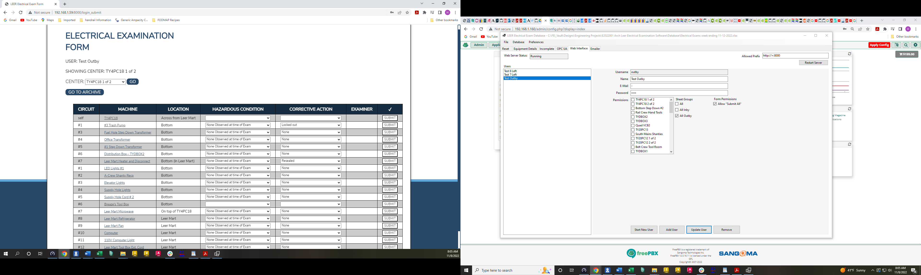

## View Archived Examination Records

This link on the login page allows anyone with access to the company network to view the examination records for the previous 52 weeks.

Select the power center in question from the drop down menu shown in the upper left corner of the page and click “go” to access the circuits for that power center.

Then click on the circuit of interest to view all the records for that circuit.

Then use the back button on your browser to return to the previous page where you can select another circuit, use the dropdown menu and the go button to select another power center or click back again to return to the login screen.

# Program/Administrative Interface

The program should reside on a server or suitable computer that is accessible from anywhere on the mine network via a preferred web browser.

Administrative tasks are handled directly in the local user Interface window.

Examiners will access a web browser to enter inspection data as shown above. A password will be required to access this site from the initial web address.

Anyone may access the data in a read only format via the same website and will be able to access all available data from the previous 52 weeks.

## Starting the Program

The program is meant to run continuously on the server.

***The program must be started as an administrator.*** Right click on the .exe file and select “run as administrator”. Either select yes on the following dialog box or enter your administrator username and password.

## Upgrading Software Versions

In the event that a software upgrade is necessary, the database.db file located in the “sql” folder where the executable file (_______Database.exe) is located should be copied from that location in the old version to the same location in the folder for the new version of the software. ***\*Note that the previous version of the software should not be deleted until after the new version is installed, the database.db file is copied and the new version is running and functional.***

## File Menu

Drop down menu includes open, save and exit options.

### Open

Opens an excel file of the users choice for the current examination period. This is used to enter a new spreadsheet with different equipment from the previous week. IE, when equipment moves or is removed from service or added to the existing equipment.

It is important for the new file to be reset and saved through the reset and save button on the Reset tab as described below. This procedure erases all hazardous conditions and correction actions as well as the examination signatures from the file. This ensures that the file is ready to receive new inspections for all the equipment listed. ***Failure follow this instruction will prevent new inspection records from being entered through the web interface.***

### Save

Allows user several options for saving the current week’s data.

#### Save as…

Allows the current data to be saved under any name in any file of the user’s choosing.

#### Save Current File

Saves the current data to the file that is currently open. A dialog box appears showing the name and location of the file to which the data was just saved. Click the ‘OK’ button to continue.

#### Save for current week

Saves the current data to a file with the date of the end of the current week.

#### Save for week…

Allows the user to select the date to be used for the name of the file to be saved.

Select the appropriate date and click OK or click cancel to exit the current diaglog window.

### Exit

Selecting this option closes the entire program. The database will not be accessible via company network through a web browser if the program is not open.

## Database Menu

### Import from Excel Directory

Selecting this option allows the user to load all the excel files in the folder selected into the program’s internal database to allow those files to become part of the archives that can be accessed through the web browser.

## Preferences Menu

This menu allows the administrator to choose preferences for how data is displayed.

### Web Page

The web page preferences allow the way data is displayed in the web access page to be changed.

#### Multiple Submission Style

The administrator’s preferences on how equipment that is allowed to have multiple examination records each week will be displayed. Column, Row Color, Button Text are selectable options in this menu. If a piece of equipment is allowed to have multiple records recorded, the web page can display a column with this information for each piece of equipment, the row color can change (with a color legend explaining such at the bottom of the browser page), and or the submission button can have a symbol added to it. Any or all these options may be used. The web page will not display changes until it is refreshed, or a new power center is selected.

## Tabs:

The following tabs allow different administrative tasks to be completed on the server for the database including database modification, network access to the database, and user interaction with the database.

### Reset tab

The reset tab displays all the machines and or circuits that require action and shows items that have been inspected and need reset prior to the start of a new week’s file. It also allows access to data to change information as in the webpage. Each record can be updated or revert to its previous state from this tab. Selecting any item in the action required or pending reset box displays the information about that individual item and allows the condition and corrective action to be changed and updated. The date when the week will be updated and automatically saved can be changed via the drop down in the lower right corner of the tab.

### Equipment Details Tab

Allows administrators to view any piece of equipment attached to any power center currently in use. It also allows the hazardous conditions and corrective actions to be changed for each item. The update button will save the change to the record. This tab includes a multiplicity selection. Default is single. Select multiple to allow records of multiple inspections each week to be recorded in the database and displayed in the archives. The multiple selections column must be in the spreadsheet currently imported into the database. If it does not exist, then the multiplicity selection will be but unavailable.

### Incomplete Tab

This tab displays the centers and individual pieces of equipment that are currently not inspected

### OPC UA Tab

This tab allows the OPC UA server address to be entered and lets the administrator connect the database to it. It also displays the status of the connection to the server. This function is not currently enabled due to lack of data required to interact with the OPC UA server in question.

### Web Interface Tab

This tab displays the clients (users with permission to add data to the database through the company network.) clicking on a client will display their information and permissions in the area to the right of the clients list. This includes username, name, email, and password. It also includes permissions as to whether they can submit all data at once for a given power center or would be required to submit each circuit separately. It also can limit the power centers each user is allowed to access. There are options to allow only inby or only outby, all power centers or individual power centers from the list.

All the data must be filled in to add a client to the list. If no email is available for the client, place a single character in the email box to complete the data for the user.

#### Restart Server Button

This button restarts the server with the allowed prefix above it. This can be changed from localchost:8000 to whatever port is necessary. The localhost can be replaced with a ‘+’ sign which will result in the addition of the ip address of the machine running the program. The actual IP address may also be included here in lieu of the ‘+’ sign.

#### Start New User button

This button clears the data from the user details area above it.

#### Add User Button

This button adds the data entered in the above user details to the client list at the left.

#### Update User Button

When a client is selected from the list at the left, the user details appear on the right. The administrator can change this data and select the update user button and change the data that exists for that client.

#### Remove button

When a client is selected from the list at the left, clicking this button removes them from database. The client will no longer have access to change the examination database.

### Emailer Tab

This tab allows the administrator to send reports on the database to any valid email address. The current list of recipients is displayed at the left. New addressed can be entered to the right of that box. The weekday, time, and details to be included in the email can be selected from the various lists shown in the window. A selected email address from the recipients list can be altered and the data updated by clicking update. Current recipients can be removed, and new recipients can be added with those respective buttons.

The program has the option to serve its own emails or to allow an SMTP server to handle the email traffic. These options are controlled from the pane in the lower right corner of the Emailer tab. If the box is unchecked, the program will send its own email, but this requires internet access. If the box is checked, the text box allows the administrator to input the desired email address and password reserved for this program. The Update button saves the data into the program.

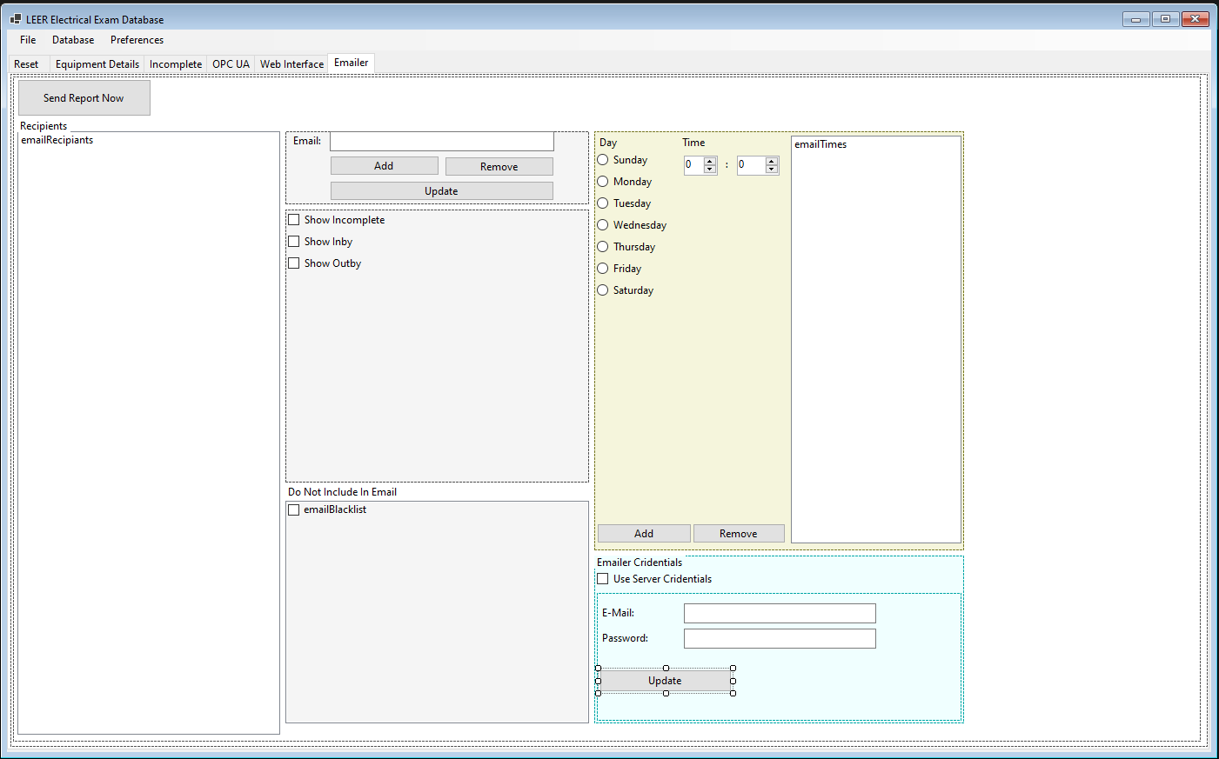

## 

## Record of User Activity

A log file will be created in the same directory as the program executable file. This file will be updated with the login and logout times for each user that accesses the web system.

Creation, deletion, and modification of user data will also be logged into this file.

A new file will be made periodically with a new start date so that data deemed no longer useful may be deleted if necessary.

# Troubleshooting

1. If the program is started without administrative permissions, the User interface may not appear. Additional attempts to start the program will fail because the program is still running. Open task manager and find the name of the program executable and end the task. The program will then be able to be started using administrative permissions. Additionally, the program may run if not started in administrative mode, but the web server will not run in this mode and the address for the web server will not be able to be changed through the user interface. The web interface will not be allowed access either.
2. Loading 52 weeks of excel files into the database may take between 1/2 hr and 1 hr on an average desktop computer. A server may only require a matter of minutes to load the data.
3. A current database must be running for the webserver to start running. Use the file menu information above to complete this task.
4. If the newly downloaded program will not start or the UI will not appear, please remove the sql database from the unzipped files. Quit the any existing tasks with the exe file name and try to restart the exe file. You will need to reload the databases and user and emailer information.
5. A problem was encountered with a “blank” signature being read from spreadsheets. The result is that when a piece of equipment is examined, the inspection won’t be saved because the program interprets the blank space as an already inspected piece of equipment. The spreadsheets were populated with an autofill scheme to allow an entire sheet to be signed with one signature at the top. This was accounted for in the program for actual signed sheets. However, when this is left blank, it is difficult to handle the information presented to the program. When the spreadsheet is reset and updated for the following week, these cells are replaced with empty cells and the problem is corrected. The only time this problem occurs is when the spreadsheet is named with the current week’s date, and it isn’t automatically corrected. The solution to this problem is to use the reset and save button in the User interface under the reset tab. This will remove the offending data as well as all the hazardous conditions and corrective actions in the spreadsheet. In addition, a sample spreadsheet will be provided with the program that is formatted to avoid this specific error. Note that the program should read historical data with this problem and display it properly.